

Developing a Puzzle Game Website Featuring Financial Awareness

A project for ***Fundamentals of Web Programming***

*1st semester-1447: (2025/2026)*

**Design Document**

By:

**Ali Fadhel Almomen** (223028854)

**Ahmed Jawad Alhassan** (223014461)

**Abdullah Adnan Almaslami** (223021574)

Supervised By: **Dr. Hafiz Farooq Ahmad**

**Version 2**

**Introduction**

The project is a web-based gaming website designed to help users develop and enhance cognitive skills through puzzle games. It also promotes financial awareness through gameplay elements. This document will detail various sides of the project, like the database structure, general overlay of the logic to be programmed, external viewpoint and other useful information that will make the process of creating the software clear and easy.

**Glossary**

|  |  |
| --- | --- |
| **Term** | **Definition** |
| HTML | HyperText Markup Language for creating web pages |
| CSS | Cascading Style Sheets for styling web content |
| JavaScript | Programming language for web interactivity |
| PHP | Server-side scripting language |
| SQL | Structured Query Language used to manage and query data in relational databases |
| MariaDB | Database management system |
| XAMPP | Cross-platform web server solution stack |
| UI | User Interface |

**Use case diagram**

This diagram highlights how components of the system are getting used abstractly.

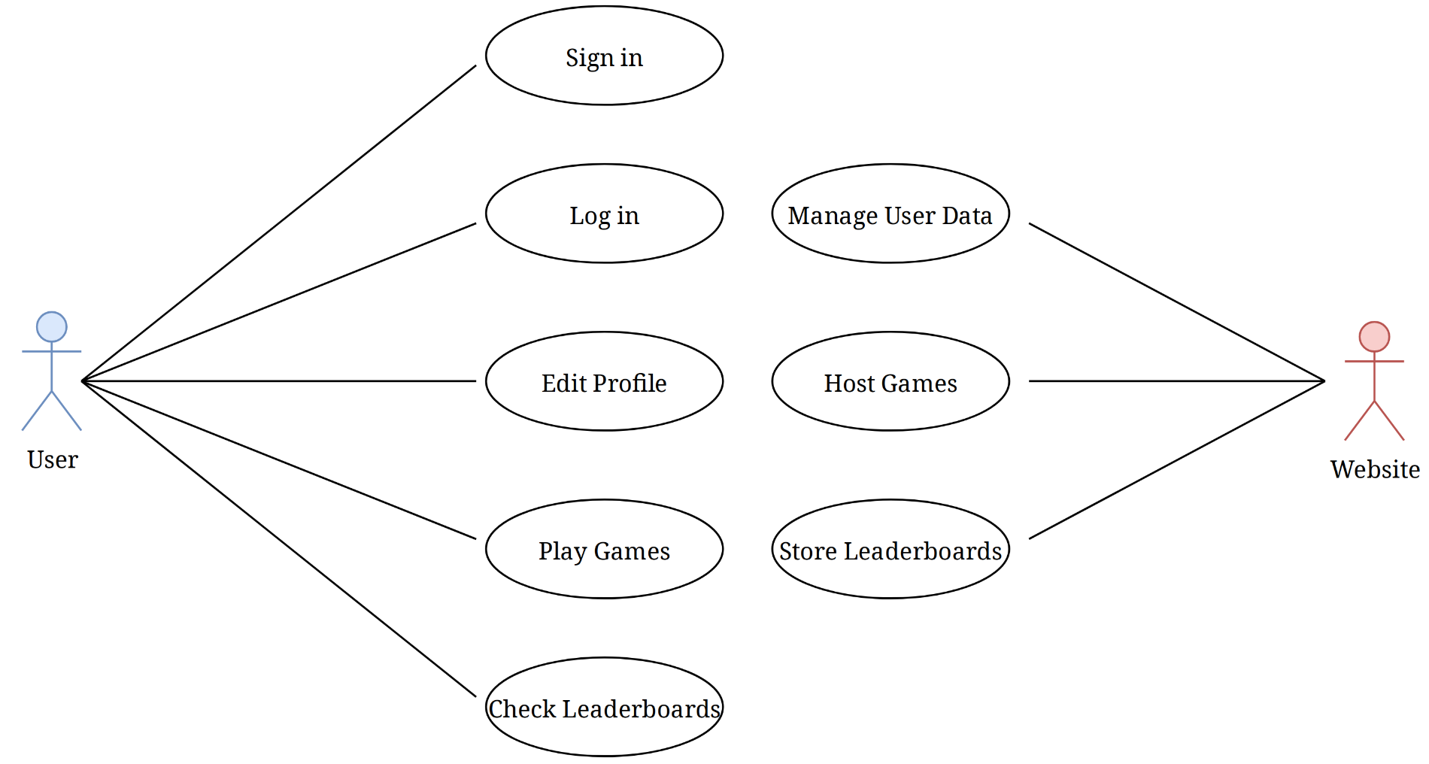

**Database design**

This is the entity-relationship model of the database, which will use an SQL engine such as MariaDB or MySQL to manage all of the user generated data.

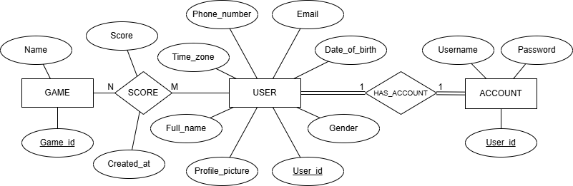

Each user has only one login, and each login belongs to one user. At the same time, the user has only one high score recorded in the leaderboard relation, and the leaderboard has many users' records.

**User Interface (UI)**

This is the planned UI for the website, designed in Figma.

